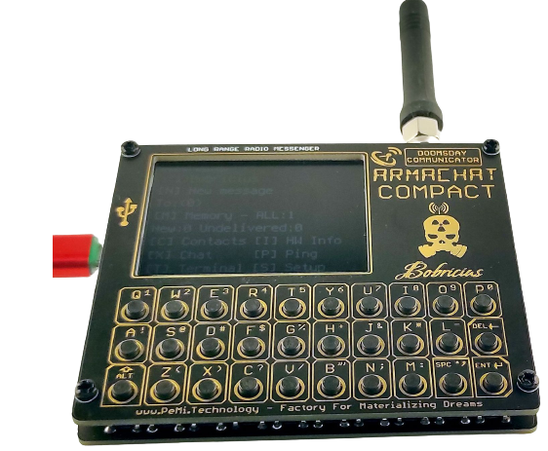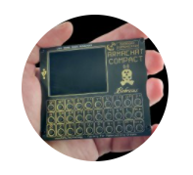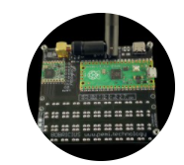

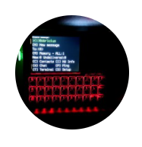

**Thank you for your purchase!**

# Introduction

The **Armachat COMPACT** is an all-new board which supersedes the earlier SAMD21E18 Armachat versions. Due to the Covid-19 chip crisis and the unstable supply of components, Bobricius decided to completely revise the design. This version uses the Raspberry Pi PICO (or RP2040 alternative) and joins the PICOComputer family by Bobricius.

The **Armachat COMPACT** is a long range, text-based radio messenger. It offers, freedom of communication without borders, operators, networks, fees! Your own network, your own rules!

|  |  |  |
| --- | --- | --- |
| * 30 key QWERTY keyboard. | * 2" IPS LCD 320x240. | * RFM95 LoRa radio module. |
| * USB-C power supply. | * Message Encryption. | * Support for alternative LCD screens. |
| * Small form factor (100x100mm). | * Raspberry Pi Pico or Waveshare/RP2040 equivalent. | * Main software in circuit python, fully open and transparent. |

Armachat has no radio device certification, usage is at your own risk and responsibility. **Armachat COMPACT** utilizes the RFM95 radio module. The allowable frequency and usage for LoRa long range radio varies by country. Typically, 868Mhz usage for UK/EU and 915Mhz for US. Please carefully check your local regulations and any applicable legal obligations at <https://www.thethingsnetwork.org/docs/lorawan/frequencies-by-country/>.

Currently as of January 2021 the Armachat firmware is in a basic stage of development and as such please check the software features. For details of software, project status, credits and any current issues refer to <https://github.com/bobricius/Armachat-circuitpython>. It is hoped that community software development by advanced users will provide sufficient maturity, in the near future!

A common question is on the communication distances that can be achieved. This is obviously hard to say given the variables involved (local topography, vegetation, building materials and density, antennae, elevations etc) and the nature of RF communications. Using a Standard RFM95 20dB output, spread factor 12, 2dB antenna the following distances were achieved in testing.

* 700m unit on garden desk.
* 1500m unit in window.
* 4300m unit on attic window, but unreliable.

Please note that this is just a single test and should only be used as a guide.

**Armachat COMPACT** is supplied in the following Package Options.

1. Bare main board only, without front panel and no components included.
2. Bare main board + GOLD front panel and no components included.
3. Assembled working units.

For Option 1 and 2 refer to the assembly guide section for details of the additional components required.

# Armachat COMPACT overview

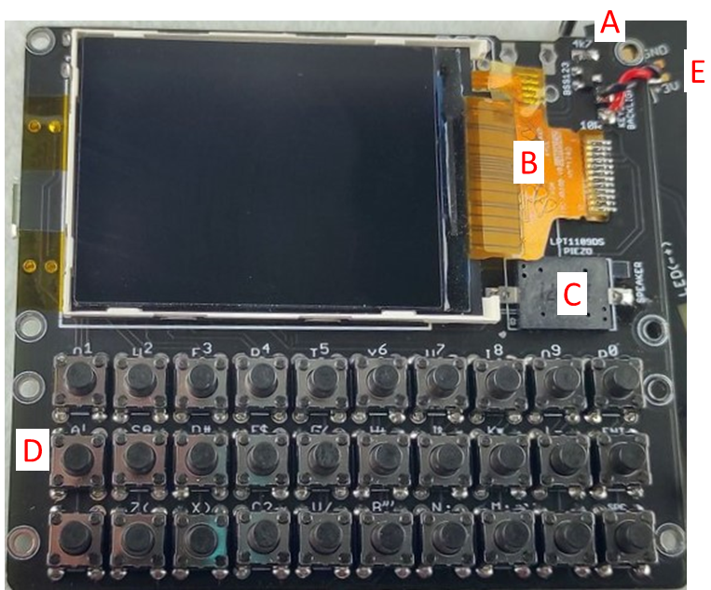**Main board – Top**

|  |  |
| --- | --- |
| **A** | **Keyboard Backlight**  **(1 No. BSS123 & 1 No. 4k7)** |
| **B** | **TFT Screen Ribbon connection** |
| **C** | **Piezo Speaker** |
| **D** | **Tactile Switches (through hole)** |
| **E** | **Solder Pads for wires to front panel** |
| *Items A to C are for SMD components.* | |

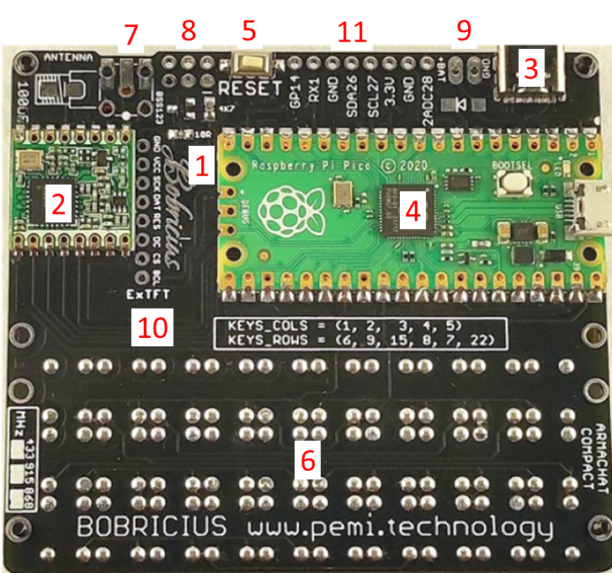**Main board - Bottom**

|  |  |
| --- | --- |
| **1** | **TFT Backlight**  **(1 No. BS123 & 1 No. 4k7 & 1No. 10R)** |
| **2** | **RFM95 Radio Module** |
| *3* | *USB-C Connector \*\** |
| **4** | **Raspberry Pi Pico** |
| *5* | *Reset Switch \** |
| **6** | **Tactile Switches (through hole)** |
| **7** | **Pads for SMA antenna connector** |
| *8* | *Power Switch (through holes) \** |
| *9* | *External Battery Connection \*\** |
| *10* | *Onboard TFT screen headers \*\** |
| *11* | *Breakout Headers \*\** |
| *\* Optional* | |
| *\*\* These are not used and unsupported but are open to developers.* | |

**Front Panel – Bottom**

|  |  |
| --- | --- |
| **F** | **Keyboard backlight LEDs** |
| **G** | **100R SMD resistor** |
| **H** | **Wire connection to pads at main board MOSFET** |
| *These items are optional.* | |
|  | |

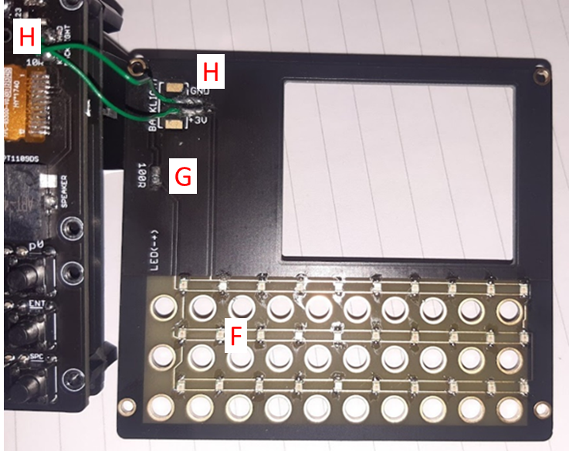

**Notes for optional/development items.**

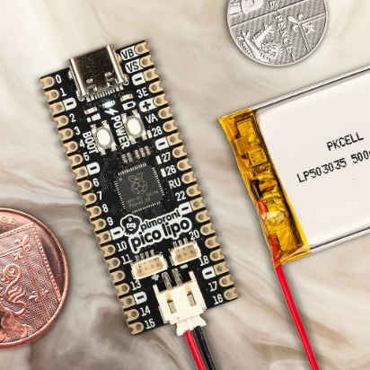Item 3. USB-C Connector

This offers the potential for a USB-C power connection. Given the variability of USB-C connectors and the difficulty in making a one size fits all on the board, it is advised that if USB-C is required then it would be easier to source a Pico compatible board with a USB-C connection (also see item 9 below).

Item 5. Reset Switch

This is a nice to have, to allow reset of the board without disconnection and reconnection of the power.

Item 7. SMA Connectors.

Note that there are options for various alternatives such as edge or right-angled connectors that can be used. The simplest and most compact is an edge connector. The 100uF SMD capacitor is optional.

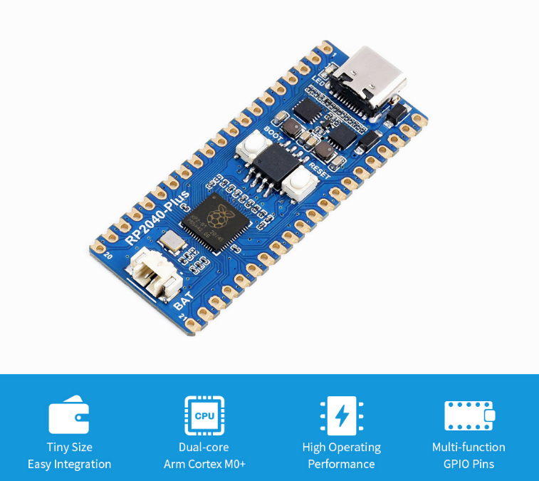Item 9. External Power/Battery Connections

It is recommended that for lipo power an alternative Pico with on board lipo charging circuit be used. An example is the “Waveshare RP2040” but others are available matching the Pico pin layout. This alternative is recommended to ensure that the battery is protected from undercharge/overcharge and any potential for overvoltage via the Pico and additional USB power port. Note the maximum voltage tolerance of the hardware.

If the battery connection points are used this will also require an SMD shockty diode installed on the pads available below the connection.

Item F. Keyboard Backlight LEDs

To switch the keyboard backlight LEDs on or off press keypad ‘q’ for on and ‘a’ for off. Check polarity of supply with multimeter and LEDs are consistently orientated when assembling.

# Assembly Guide

For those who have purchased the Package Option 1 or 2, please find below a bill of materials to assist with sourcing the correct components to assemble the board.

**Bill of Materials (BOM)**

**\*Position is as marked on the board and/or as indicated in the overview above.**

**\*\* Example supplier to be used as a guide for alternatives.**

| **Line #** | **Component** | **Pcs** | **Description** | **Note** | **At Position\*** | **Example supplier\*\*** |
| --- | --- | --- | --- | --- | --- | --- |
| 001 | Power MOSFET, N Channel, 100 V, 170 mA, 2.98 ohm, SOT-23, Surface Mount | 2 | MOSFET for Keypad LED power | Optional for Keyboard LED only | A | 726-BSS123NH6327 MOSFET MOSFET N-Ch 100V 190mA SOT-23-3 (Mouser)  Ordercode 2575356 Manufacturer No BSS123L (Farnell UK) |
| 002 | 4K7 SMD 0603/0805 | 2 | Resistor for Keypad LED power | Optional for Keyboard LED only | A | 755-SDR03EZPJ472 Thick Film Resistors - SMD 0603 4.7Kohm 5% Anti Surge  AEC-Q200 (Mouser)  Ordercode 3399582 Manufacturer No CRG0603F4K7 (Farnell UK) |
| 003 | 12 pIn serial port SPI LCD | 1 | LCD Screen | Alternatives are possible refer to Hardware links below. | B | 2.0 inch serial port SPI 2 inch IPS LCD screen 12PIN QVGA320240 ST7789V (AliExpress) |
| 004 | Transducer, 1 V to 25 V, Single, 75 dB, Sounder, 1 mA, SMD | 1 | Speaker/Beeper |  | C | 497-TP114105-2 Speakers & Transducers Piezo (Mouser)  Ordercode 2433031 Manufacturer No MCABT-458-RC (Farnell UK) |
| 005 | Power MOSFET, N Channel, 100 V, 170 mA, 2.98 ohm, SOT-23, Surface Mount | - | MOSFET for LCD Backlight power |  | 1 | - |
| 006 | 4K7 SMD 0603/0805 | - | Resistor for LCD Backlight power |  | 1 | - |
| 007 | 10R SMD 0603/0805 | 1 | Resistor for LCD Backlight power |  | 1 | 755-ESR03EZPF10R0 Thick Film Resistors - SMD 0603 10ohm 1% Anti Surge  AEC-Q200 (Mouser)  Ordercode 3399589 Manufacturer No CRG0805F10R (Farnell UK) |
| 008 | RFM95 Module | 1 |  | Select correct frequency for region | 2 | RFM95W-915S2-ND : RX TXRX MODULE ISM < 1GHZ SMD Digikey (1) |
| 009 | Raspberry Pi PICO or RP2040 Alternative | 1 |  | Refer to notes on RP2040 options and charging. | 4 |  |
| 010 | Tactile Switch, KSR, Top Actuated, Surface Mount, Round Button, 300 gf, 50mA at 32VDC | 1 | Reset Switch | Optional | 5 | Ordercode 1201422 Manufacturer No KSR231G LFS (Farnell UK) |
| 011 | DTS63K | 30 | tactile switch 7mm height, 1N | 1N force is recommended | D/6 | 642-ADTS63KV Tactile Switches Tactile Switches SW TACT 12VDC (Mouser) Ordercode 9471723 Manufacturer No MCDTS6-3K (Farnell UK) |
| 012 | Slide Switch, DPDT, On-On, Through Hole, JS, 300 mA | 1 | Slide Switch | Optional | 8 | 611-JS202011CQN Slide Switches Slide Switches DPDT THRU HOLE .3A (Mouser)  Ordercode 2320018 Manufacturer No JS202011CQN (Farnell UK) |
| 013 | LED, Red, SMD, 0805 [2012 Metric], 20 mA, 2.2 V, 630 nm | 30 | Red LEDs | Optional | F | 743-IN-S85CS5R Standard LEDs - SMD Standard LEDs - SMD Red LED Mouser Ordercode 2829445RL Manufacturer No SML-H12V8TT86C (Farnell UK) |
| 014 | 100R SMD 0603/0805 | 1 | Resistor for LEDs |  | G | Ordercode 2073352 Manufacturer No MCMR06X101 JTL (Farnell UK) |
| **Optional Items (not supported, please review fit)** | | | | | | |
| - | USB-C Connector | 1 |  | Please review fit. As previous notes it is recommended to use an alternative RP2040 board with USB-C | 3 | 640-USB4105-GF-A USB Connectors USB Connectors USB Type C,2.0,  Rec,SMT,TH Shell Stakes,G/F,RA,Top Mnt,T&R (Mouser) |
| - | Small Signal Schottky Diode, Single, 30 V, 200 mA, 350 mV, 600 mA, 150 °C | 1 | Diode for Battery Connection | Please refer to note on the use of Lipo batteries – upstream protection circuits are required or alternative RP2040 board with Lipo Charging. | 9 | Ordercode 1651157 Manufacturer No BAT54T1G (Farnell UK) |
|  |  |  |  |  |  |  |
| (1) Select correct module for your region. | | | | | | |
| **Mechanical Fittings** | | | | | | |
| 015 | M2 x 12 screw | 4 | Black nylon screw | Used for mounting front panel | Corners of board | <https://www.amazon.co.uk/gp/product/B09439W4WJ/ref=ppx_yo_dt_b_asin_title_o01_s00?ie=UTF8&psc=1> |
| 016 | M2 washers | 16 | Black nylon washers/spacers | 4 Spacers between main and front board | Corners of board |
| 018 | M2 x 6 standoffs | 4 | Black stand off for bottom end of board | Feet for main board | Corners of board |
| **Some trial is required to suit your layout** | | | | | | |

**Assembly instructions**

Soldering the components should be relatively simple for those with some soldering experience and access to suitable soldering tools.

If you are not experienced with SMD, take your time, and relax. I recommend good magnification; you can improvise a microscope from a cell phone - in video mode at maximum zoom to help! Bobricius has some useful videos on his YouTube channel. <https://www.youtube.com/watch?v=PBCdbF2fIsc&ab_channel=PeterMisenko>

Start by studying the PCB, both sides and the location of items. I like to perform dry fits where needed so that you have an idea of where everything should go and what might get in the way when soldering. Check polarity of the diodes and LEDs before assembly and remain consistent in the orientation where applicable.

For the Raspberry Pi PICO installation, I recommend using temporary header pins or bent wire pins to locate and align the board. Make sure the board is in the right orientation, tack in place then remove the temporary pins and solder all edge holes to finish. Note that you could socket the Pi PICO for removal, by using female headers on the board, but be aware that this will increase the thickness of the installation which may get in the way of future development.

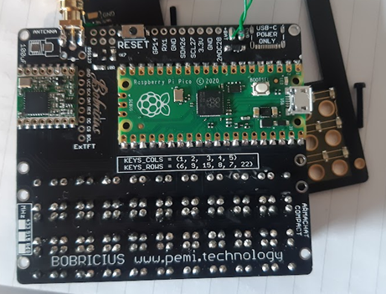I recommend the following sequence when soldering the board together, starting with shortest height items first:

* Keyboard LED backlight resistor and MOSFET
* Slide Switch on back of board. Note that it can’t be on the front as it will interfere with the LCD. If installed, then the pins will need trimming as low as possible to avoid the LCD.
* LCD header
* Speaker
* LCD backlight resistors and MOSFET
* RFM95
* Pico
* Tactile switches
* SMA connector
* Reset button (if required)
* Front panel LEDs and resistors, if required.

|  |  |
| --- | --- |
|  |  |
| *PICTURE* | *PICTURE* |

# Software Installation

Once assembly is complete you are ready to install the Armachat software to the board. There are two main steps.

1. Upload of the CircuitPython binary to the Raspberry Pi Pico board.
2. Upload of Armachat COMPACT code to the flash memory.

The CircuitPython binary is available from

<https://circuitpython.org/board/raspberry_pi_pico/>

The Armachat COMPACT code is available from

<https://github.com/bobricius/Armachat-circuitpython>

**Step 1 - Uploading CircuitPython binary to the Raspberry Pi Pico**

1. Make sure that the board is in flash memory mode. Hold the reset button on the Pico and connect it to the PC.
2. The Pico will now show as a USB storage device.
3. Copy the circuit python binary to the board and allow it to reboot.
4. Once it has rebooted the USB storage will show some directories – delete all of these.
5. Proceed to Step 2.

**Step 2 - Uploading Armachat COMPACT code to the Raspberry Pi Pico**

1. Download the Armachat-circuit python code as a zip file using the green code button. Save to your PC.
2. Right click and extract all to a folder.
3. Browse to the software folder “…\Armachat-circuitpython-main\Armachat-circuitpython-main\Software”
4. Copy all files except those named “code TEST…py” to the Pico flash.
5. Once copied the Pico should reboot and now you are ready to go!

**Tips on Settings**

* Limited setting can be altered, such as username by editing the config.py in the config folder.
* ‘Q’ and ‘A’ - keys switch the LED backlight on and off respectively.
* ‘N’ - for new message.
* ‘Alt’ - changes case and to numbering.
* When composing a message – use ‘alt’ to change to uppercase and the ‘del’ and ‘ent’ keys can navigate up and down a message line.

Please note that the current code, whilst functional, is under development.

# References and Credits

**Hardware by Bobricius**

<https://www.tindie.com/products/bobricius/armachat-lora-messenger-with-raspberry-pi-pico/>

<http://pemi.technology/>

**CircuitPython firmware**

<https://circuitpython.org/board/raspberry_pi_pico/>

**Armachat Software**

<https://github.com/bobricius/Armachat-circuitpython>

**User Guide**

AdamT @AdamT117 <https://twitter.com/AdamT117>